**

**N° 01. Nijmegen, Tuesday, January 23, 2018**

It is still cold outside, exams are everywhere and you’re still working on those new year’s resolutions. Before we succumb to all the stress, we want to update you on the latest news, activities and intrigue your brain with our olden golden fun fact.

**Donders Cube**

Although it has been a few weeks ago, we would like to share something very awesome with you! On december 21st Dondrite won the Donders Cube award for their contribution to the Donders Institute. The Donders Cube was founded to acknowledge outstanding individual or group contributions to the Donders Institute as a whole. Therefore, we are very happy and appreciative that our efforts have been noticed, not only by the students but also by the institute. While handing us the award, David Norris elaborated on how Dondrite has a positive influence on the studies of the Dondrites. In sum, this award shows that hard work pays off! So congrats to all Dondrites for making this happen!

**Recent Dondrite Activities**

**MATLAB Session:**

On the 12th of January a Matlab session was organised during which students could ask questions and practice a bit more with Matlab. There were quite some responses and we were happy that many of you came to the session and found it very useful. We hope that this quick practice session helped you nail that advanced math exam!

**Upcoming Dondrite & Donders Activities**

**Introduction:**

A new semester means new students and we can’t wait to meet them! As is the tradition, there will be a Dondrite introduction for the new February starters. Since they are a smaller group, it looks a little different than the September introduction. However, we will end with a Borrel in the Cultuur Cafe for which all of you are invited. This is a great opportunity to meet the newbies and make them feel welcome!

**Info:** T.B.A.

**Dondrite Spotlight:**

This month's spotlight will have a host to talk to us about brain and evolution! After his lecture, there will be room for the discussion. In the track of cognitive neuroscience we study human behavior and the brain structures underlying this behavior. Yet, why do we behave like we behave? Where does our cognition come from and what makes us human? Miles Wischnewski is going to tell a story about our first steps to our most impressive cognitive achievements. He will go into the details of how our ancestors changed over time physically and mentally. Finally, in the last 30 minutes, changes in the brain will be briefly discussed as well as how our brain grew to a size 4 times bigger than just 3 million years ago. We are looking forward to this lecture, as he has been wanting to give a lecture for quite some time and is very passionate about his field. We hope to see many of you on the 15th of February.

**Info:** February 15, time and location: T.B.A.

**Gala Through the Looking Glass:**

Ahh, the Dondrite&Donders Gala. Mythical, mystical, magical! Many of you will still be reminiscing about last year’s gala and the first years will be bursting with anticipation and excitement! The wait is almost over, the theme is finally revealed and the ticket sale has opened. There will be live music, photographers, drinks and snacks. The only thing we need to make this party unforgettable, is you! Bring partners/friends/your favourite lecturer, dress or suit up (the Dondrite activity committee does not mean to inflict gender roles on anyone, please wear what you feel comfortable in) and make sure to buy your tickets before they run out!

**Tickets:** [www.ticketkantoor.nl/shop/ttlg](http://www.ticketkantoor.nl/shop/ttlg)

**Info:** February 2 22:00, de Hemel  
**Facebook:** [[link]](https://www.facebook.com/events/1477107265736058/)

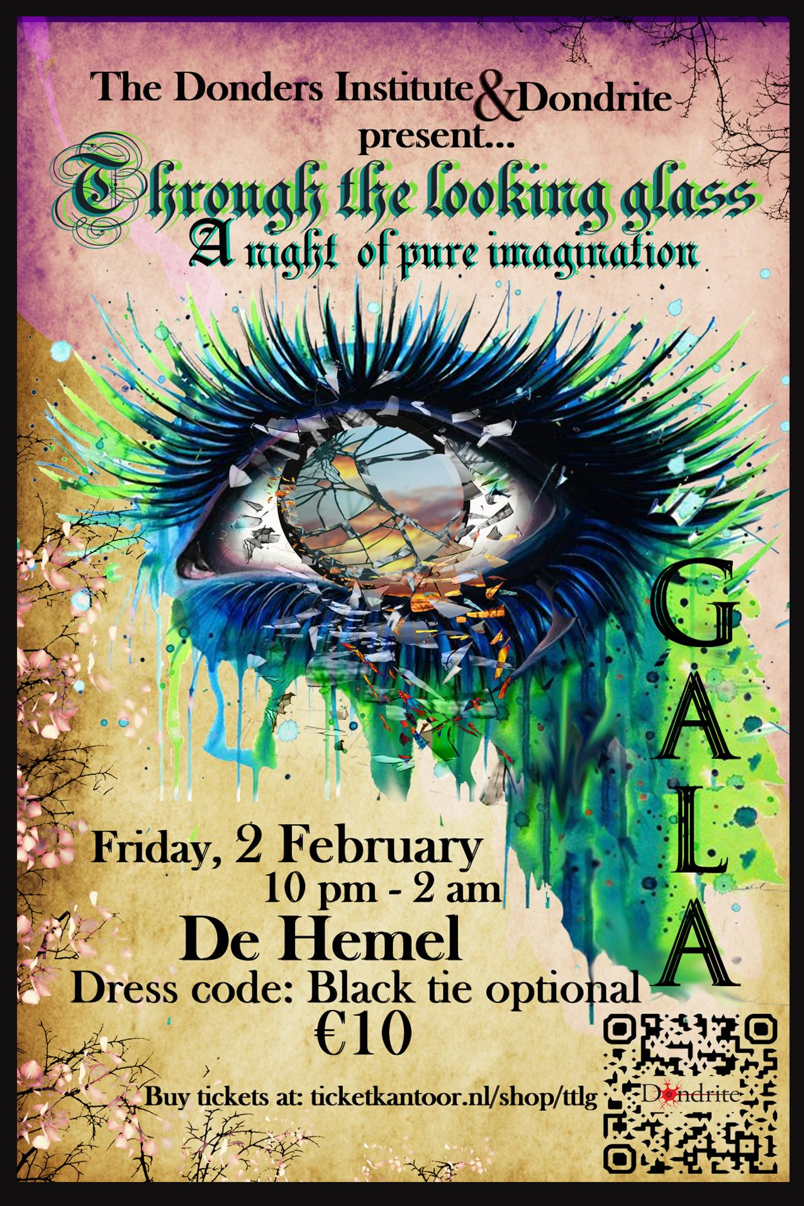

|  |  |
| --- | --- |
| **Upcoming Donders Events:** | **Date:** |
| **Informal Lecture Devika Narain**  [[url]](http://www.ru.nl/donders/agenda/agenda/@1142054/informal-dcc-lecture-devika-narain/) | Friday, February 2nd,  09:30-11:00 |
| **Dondrite Gala** [[url]](http://www.ru.nl/donders/agenda/agenda/@1136233/20180202-dondrite-gala/) | Friday, February 2nd,  22:00-02:00 |
| **Public Lecture** Making the Green Choice [[url]](http://www.ru.nl/donders/agenda/agenda/@1143119/public-lecture-making-green-choice/) | Wednesday, February 7,  19:30-21:00 |
| **Donders session**  Small vessels, big trouble! [[url]](http://www.ru.nl/donders/agenda/agenda/@1143119/public-lecture-making-green-choice/) | Thursday, February 15,  13:00-14:30 |
| **DCCN Colloquium Trevor Chong**  Lecture [[url]](http://www.ru.nl/donders/agenda/agenda/@1128127/dccn-colloquium-trevor-chong/) | Monday, February 19,  13:00-14:00 |
|  |  |

For more information see:<http://www.ru.nl/donders/agenda-news/agenda/>

**Fun Fact**...It is time for another fun fact about whales, with which you can amaze your family! Though I am not sure whether an orca really is a whale. That may be a topic for the next fun fact. At least it is about the fact that people in Spain made up a nickname for the orca: ‘killer whale’. This is because they were first referred to this by sailors who witnessed their attacks on larger cetaceans, and over time this name was changed to "killer whales”.