Policy Plan

2018-2019

Dondrite-Study Association of the Research Master Cognitive Neuroscience

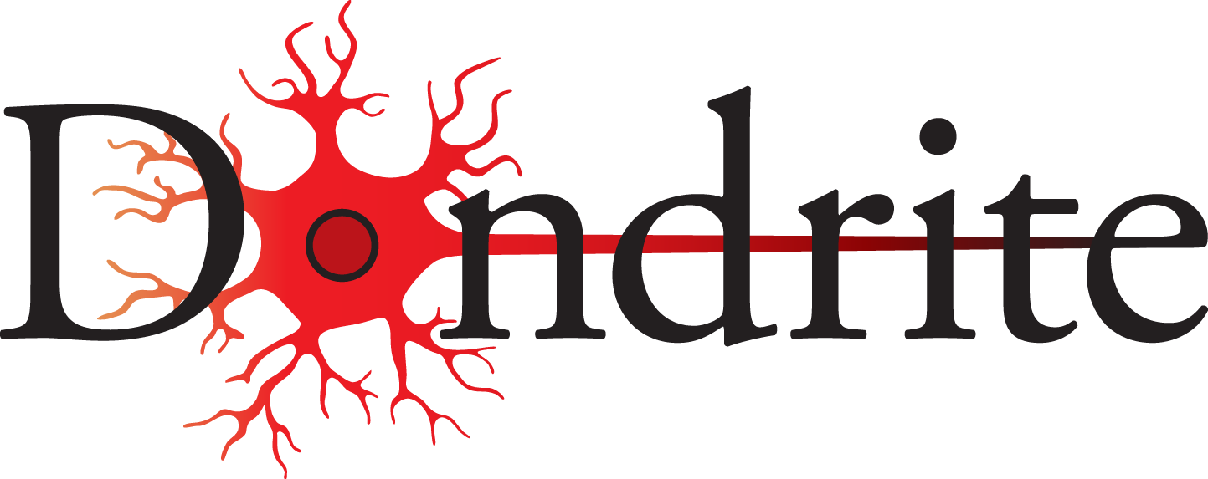

Nijmegen

August 2018

Tineke Banda, Wessel Hieselaar, Viola Hollenstein, Tabas Shuja

Table of contents
Table of contents 1
Introduction 2
Culture amongst students 3
Visibility 4
Integration 5
Board transition 6

Introduction

Dear member of Dondrite,

In front of you lies the document containing the goals of the Board of Dondrite for the year 2018-2019. These goals are partially based on the general Dondrite policy plan, which conveys why Dondrite was created 2 years ago. Dondrite was founded to serve several long time objectives that will always be worked towards. Besides those goals, each year the Board comes up with subgoals and prioritises them according to what they think the association needs at the time. In this document you can find the goals for 2018-2019. For every goal we have this year, we will explain how we plan to achieve it. We also explain why this goal is something we want to achieve. You may also notice that most goals are related to each other, as we believe these goals cannot be achieved in isolation and every method devised to reach this goal will also aid in reaching another goal.
Should you have any suggestions on how to improve the study association further, don’t hesitate to let us know either personally, via email, social media, or via the suggestion box on the website.

In general, we like the progress Dondrite is making and we want to consolidate that. The best way to ensure the durability of our association is to make sure we are flexible, so Dondrite can connect to the wishes of the members. We have several ideas on how to do this in 2018-2019.
We would like to note that we will continue with most of the policies instantiated by the previous Board, such as sending new members a welcome letter, having a free trial period of a month for new starters, ordering t-shirts for members and organising meet-the-committee events every half year.

Best,
Tineke, Viola, Wessel and Tabas

Culture amongst students

Goal:
To make students feel at home and create a group-feeling amongst Dondrites.

Justification:
Most important to a study association is a welcoming environment where members feel at home. We think people are more likely to go to events when they know they can expect friends to be there and they know they will have a good time. If a group-feeling and Dondrite-feeling is present in Dondrite members, we think members are more likely to stay involved and active within Dondrite, by attending activities and partaking in committee work. One of the other reasons members might let an event go by is stress and a lack of time due to the high demands of the programme. We have noticed signs of stress within ourselves and the students of CNS, which we hope to alleviate with Dondrite.

How to achieve:
To create a group-feeling within Dondrite we would like to do the following things:
- Create more cohesion within and between committees. To do this, the Board will organise something like a night at a pub for active members every two months. Committees will also be encouraged to work together to organise shared activities. For example, the Scribe committee can work closely with other committees in writing the Dondrite News and other committees can make use of the Scribe committee to promote their events.
- Stimulate a Dondrite culture with its own traditions and customs. By having set traditions, new members can be welcomed into Dondrite more easily and will feel at home faster. Understandably, traditions cannot just be set. We aim to introduce such traditions by having a few traditional events coming up every year which members can expect to occur every year (e.g. bowling with the Activity committee or the Travel committee’s big trip). The Board will also add smaller and more casual activities to the year at a regular interval, to ensure that there are events that members with less time (e.g. due to their internship) can attend easily.
- Organise a yearly discussion panel (as started last year) to discuss the causes and effects of stress and how to handle stress whilst studying.

Visibility

Goal:
To increase visibility of Dondrite and its committees towards students of the Master Cognitive Neuroscience, as well as to other members of Dondrite.

Justification:
Being visible to both the members and the outside world is key in order to keep a sufficient amount of members and to keep its members well informed. By being visible, we both hope to increase the ‘we’-feeling of Dondrites, as well as acquiring new members. This goal is the same as one of last year’s goals. However, we wish to continue with and expand on what was achieved over the last year.

How to achieve:
To increase visibility we would like to do the following things:
- Order merchandise with the Dondrite logo for both active and general members of Dondrite. This merchandise can be given away as prizes at events or be bought from the Board at a discount for Dondrite members. This idea was already suggested at the last general assembly (GA), and mugs have been ordered. We will continue this idea the coming year by setting aside some money for a new type of merchandise, which can be bought by members for a cheap price, or serve as a prize for certain events.
- Be more present and active on social media. This does not only pertain to the Board and their activities, but to all committees as well. We would like to show what Dondrite is doing, in order that people that were not present at activities can still get a taste of what they missed. We also hope this will clarify what committee or Board work entails. This might incentivise people to either become members or become more active members by joining a committee or the Board.
- Increase the use and visibility of Dondrite’s website (www.dondrite.ruhosting.nl). We have an amazing website, but currently it is not used very much. We will add more information to it and promote the use of it by our committees and the members. For example, we will provide a link to the sign-up page on the website rather than a direct link to the sign-up form in messages to our members. The website will be a hub of information, to which members can always go for Dondrite-related things. For example, the website has a calendar that shows the upcoming Dondrite events, for which you can sign up using the links on the website. This can then be promoted on social media or the Dondrite News.

Integration

Goal:
To increase the integration between new and existing members of Dondrite, as well as promoting the integration of international students within the Dutch system and Dondrite. Similar to last year, we aim to increase the involvement of second years despite their internships.

Justification:
Dondrite is a happy bunch of people and most important for this is that everyone gets along. For this, Dondrite requires a good integration of all students. No matter in what year you are, where you come from, everyone should have fun. We have noticed that international students, as well as new students, are sometimes hesitant to participate. We want to find what causes this and ensure that they feel comfortable with Dondrite’s way of handling things.

How to achieve:
- To welcome new students, we will streamline the introduction and events at the beginning of the year. Our committees have created an overview of the events they will most likely be organising the coming year. We will also organise an information event for new (international) starters, where they can ask questions about practicalities in the Dutch university system and living in The Netherlands. We want this information event to occur every year for all new students.
- Set up a buddy programme, where new and existing students are paired up in groups. The set-up will be performed by the Activity committee, after which the groups are free to do what they want. This buddy programme is also open to non-Dondrite students and will run for the entirety of the year (and maybe even beyond that!).
- Make it easier for new and existing members to orient on committees and the Board by supplying more information about both. We will distribute relevant information more often and more casually. A beginning to the latter is already made by creating new organograms detailing how Dondrite, its committees and the CNS programme are related. These organograms can be presented often at introductory events or GAs.

Board transition

Goal:
To aid the transition of new Board members into the Board and to increase the amount of interest in the Board.

Justification:
Dondrite is a young association, and only three changes to the composition of the Board have been made. Members often seem hesitant to apply to the Board. Additionally, we have noticed that the new Board members find it difficult to settle and find their position within the Board. Furthermore, there is rather a low turnout to the GAs. However, it is vital for Dondrite to have at least some people to take care of the general issues (membership, budget, etc.) and to have general members present to vote on the proposals by the Board. At the last GA, a discussion was had on the reasons behind the low number of applicants. The conclusion of this discussion was to increase the amount of information presented about the Board and what they do.

How to achieve:
- We introduce a transition period after a GA where a new member is accepted into the Board. This transition period will be an overlapping period where the old and new person for that role are in the Board at the same time. This new member might not have any or much experience in this environment and might need time to get used to it and grow into their role. The Board script, a guideline for the Board members, already exists and will be improved upon by each Board as they progress through the year. However, we feel that the script lacks some practical information. To obtain this and more all-round knowledge, the transition period is created. If a Board member will leave the Board, they (if available) will stay for a month after the GA where they are voted out and mentor the new Board member.
- To increase the knowledge on what the Board does, we employ some of the points mentioned before in this policy plan. The Board will have a more active presence on social media and at Dondrite events. The Board will organise small and casual events ourselves, where the Board members are present. We hope this will increase the amount of applications for the Board.
- Increase the enthusiasm amongst people in regard to the GAs. We will first try this by supplying drinks and snacks at the coming GA to emphasise the fact that a GA is about Dondrite members discussing and deciding together what to do with the association, rather than a formal meeting where the Board discusses what they are going to do. Information on the GA will also be given more often and more clearly.

