Policy Plan

2019-2020

Dondrite-Study Association of the Research Master Cognitive Neuroscience

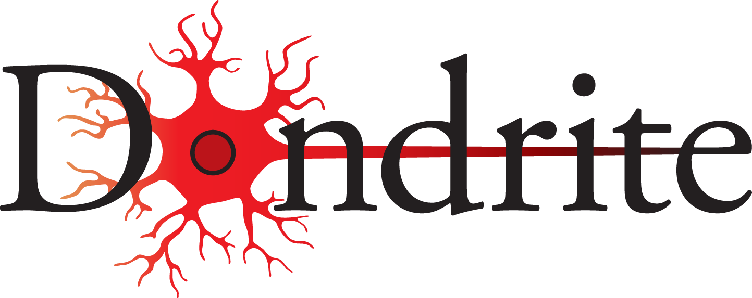

Nijmegen

April 2019

Harshil Vyas, Charlotte Jonker, Karolis Degutis, Tineke Banda, Viola Hollenstein

Table of contents
Table of contents 1
Introduction 2
External Sponsorship 3
Networking 4
Transfer of knowledge 5
Digitization (DigiDrite) 6

Introduction

Dear member of Dondrite,

In front of you lies the document containing the goals of the Board of Dondrite for the year 2019-2020. These goals are partially based on the general Dondrite policy plan, which conveys why Dondrite was created 3 years ago.

Dondrite was founded to serve several long time objectives that will always be worked towards. Besides those goals, each year the Board comes up with subgoals and prioritises them according to what they think the association needs at the time. In this document you can find the goals for 2018-2019. For every goal we have this year, we will explain how we plan to achieve it. We also explain why this goal is something we want to achieve. You may also notice that most goals are related to each other, as we believe these goals cannot be achieved in isolation and every method devised to reach this goal will also aid in reaching another goal.
Should you have any suggestions on how to improve the study association further, don’t hesitate to let us know either personally, via email, social media, or via the suggestion box on the website.

In general, we like the progress Dondrite is making and we want to consolidate that. The best way to ensure the durability of our association is to make sure we are flexible, so Dondrite can connect to the wishes of the members. We have several ideas on how to do this in 2018-2019.
We would like to note that we will continue with most of the policies instantiated by the previous Boards, such as sending new members a welcome letter, having a free trial period of a month for new starters, ordering t-shirts for members and organising meet-the-committee events every half year.

Best,
Harshil Vyas, Charlotte Jonker, Karolis Degutis, Tineke Banda, Viola Hollestein.

External Sponsorship

Goal:
To find external sponsors who will be able to contribute financially and/or in relation to the education and future careers of Dondrites

Justification:
For the past few years Dondrite was able to spend more than it earned within one financial year. As the budget’s yearly roll-over begins to stabilize, Dondrite must seek external sponsors to maintain the same expenditures as in previous years without having to cut-down on subsidies to the committees. Furthermore, Dondrite can take the opportunity to have companies related to cognitive neuroscience (or in which former cognitive neuroscientists work) promote themselves and educate Dondrites about possible career paths and opportunities within their respective companies.

How to achieve:
- We have created a brochure for potential sponsors which indicates several offers that the companies can take-on (such as giving workshops, lectures on potential jobs etc.) Each of the offers has a given price and also would require a certain number of Dondrites to attend. One way the brochure will be distributed is via email after a Dondrite committee has an event which has external companies present (e.g. Education’s Career Event or the Synapsium conference). As a result of distributing the brochure, we would like to start forming long-lasting interactions and partnerships with companies which could sponsor Dondrite throughout the years to come. The Board has created a new position of ‘external affairs officer’ who will be in-charge of given tasks.
- As an addition to having a dedicated pub for informal gatherings, we would like to receive discounts or sponsorship from a food-vendor. Since large corporations will hold limited interest in Dondrite, we aim to find a local Nijmegen-founded cafe/restaurant which serves a variable selection of relatively cheap meals. We will also seek to extend the sponsorship with our current pub or arrange a new sponsorship with a more favorable one.
- We will encourage committees to find sponsors for themselves, as several of them have in the past years. All committees will be able to gain knowledge regarding sponsor recruitment from the Board. A meeting (or Google Doc) for all ‘external affairs’ committee members will be organized to share know-how on sponsor recruitment.

Networking

Goal:
A primary purpose of Dondrite has been to increase integration between new and existing members, international students and the Dutch, and first years with the second. We now aim to extend this integration across all levels of the Donders Institute, as well as provide career-focused networking opportunities with our external sponsors.

Justification:
Dondrite is a young association with eager, fledgling Neuroscientists joining the association and the CNS master each year. We acknowledge that first arriving at the Donders Institute can be intimidating, given the space being shared by people across all levels, from bachelor interns to PhDs, and Principal Investigators with years of experience. Dondrite therefore aims to bring all these ideas and concerns together to help students acclimatize with their new learning environment by giving the students a chance to interact and get to know their academic surroundings in an organized yet informal setting outside the classroom. We also aim to help members explore their future opportunities during networking events with Dondrite’s external sponsors to provide everyone a headstart for their future after the master, and develop long-lasting connections in the field of Neuroscience.

How to achieve:
- Informal interviews with Principal Investigators/Professors/PhDs/Postdocs (researchers working at Donders) hosted by Dondrite students to aid communication outside of the classroom and lab setting, and build connections across the scientific hierarchy in Dondrite and Donders
- Promote opportunities through events with Dondrite’s external sponsors: build connections with Dondrite alumni, Neuroscience startups, and companies in the Netherlands that focus on Neuroscience or related research/application.
- Host a networking space on Dondrite’s website where members can explore opportunities in Neuroscience: they will be able to browse through vacancies offered by Dondrite’s sponsors and find information regarding workshops and conferences being hosted by them / by others in the country.

Transfer of knowledge

Goal:
To build on the establishing clear structure for committees to help them in smoothly carrying out their committee’s tasks, and to improve on the transition of new members into committees and the Board.

Justification:
Dondrite is still a young study association and we would like to work on getting more streamlined practices into place as we continue to progress. As committees are at the heart of our association, we think it’s important that they function as smoothly as possible, and for that it can help to have clear structure and exchange experiences between committees and older and newer committee members/committees from previous years. We also think, as last year, that the process of Board transition can still be improved upon, mainly with regards to how to approach the more bureaucratic parts of being on the board.

How to achieve:
- Streamline introduction meetings per committee at the beginning of both semesters, guided by the respective Board supervisor. This is with the aim of establishing a defined structure and functional roles within the committee.
- Have role-specific meetings for certain roles within the committee twice a year. This is to help committee members in finding their way in how to fulfill these roles for their committee and encourage the exchange of experiences of what works well between committees.
- Keep on building on and updating the current committee scripts.
- Encourage committees to use a standardized agenda/meeting minutes template.
- When new Board members are introduced onto the Board, put more emphasis on the bureaucratic parts that being part of the Board entail. We would like to go over important documents such as the budget and policy plan, since it’s important that every board member understands these, earlier in people’s board career, to get people to feel more ready for policy making themselves.

Digitization (DigiDrite)

Goal:
To build on the online presence of Dondrite, to increase our visibility towards Dondrites, and external parties involved with our association.

Justification:
Dondrite has a website and several social media platforms, which we can use to present ourselves online, as well as increase the flow of information and feedback. A good online presentation can help us make all necessary information easily available for Dondrite members. Apart from that, we can use our online presence to attract potential new sponsors and provide our website, as well as social media potentially, for them as a way of marketing themselves towards our members. As we have recently worked on a system to provide automatically generated website accounts for anyone who signs up to be a Dondrite member, we think we could now also work more on providing content that people would like to visit our website for, and continue such processes of automatization to make this easier for us and future (Board) members. Increased website usage will provide incentives for potential sponsors to pay for advertisements.

How to achieve:
- Increase use of website by including more exclusive content for Dondrite members. For example, photos and networking possibilities.
- Use polls on the website to get more input from (active) members and better cater to their needs.
- Improve consistency and quantity of social media presence through committees.
- Automatise digital processes with regards to member administration and account management as to relieve workload for Board members.
- Improve involvement with general Dondrite matters by breaking down information to bite-size highlights and promoting member input through the website and/or social media.

