Decision-Making:

Living Life By Your Own Design



Starting study/career

Changing environment

/relationship



Changing or stopping study/career

Complying with / Going against ext.

influence/idea

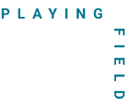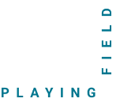

Family

Media

Culture

Society

Religion

Law

Nature

Friends

Changing environment /relationship

Starting study/career

Changing or stopping study/career

Complying with / Going against ext.

influence/idea



Society

Family

Media

Culture

**External Preamble**

**Internal Preamble**

Passion / Goal / Dream

Obligation / Opportunity

Intuition

Advice

Uncertainty

Personal needs

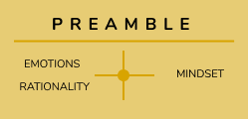

Law

Religion

Nature

Friends

Changing environment / relationship

Starting study/career

Changing or stopping study/career

Complying with / Going against ext.

influence/idea



Society

Family

Culture

Media

**External Preamble**

**Internal Preamble**



Passion / Goal / Dream

Obligation /

opportunity

Law

Religion

Advice

Intuition

Uncertainty

Personal needs

Nature

Friends

Changing environment / relationship

Starting study/career

Changing or stopping study/career

Complying with / Going against ext.

influence/idea



Media

Culture

Family

Society

**Internal Preamble**

**External Preamble**

Passion / Goal / Dream



Obligation /

opportunity

Law

Religion

Intuition

Advice

Uncertainty

Personal needs

Nature

Friends

Changing environment / relationship

Starting study/career

Changing or stopping study/career

Complying with / Going against ext.

influence/idea

New personal / professional experiences

New relationships

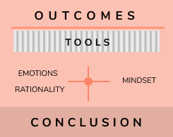

New feelings

Learning

Existing / new challenges

New understanding



Family

Culture

Media



Society

Religion

Friends

**External Preamble**

**Internal Preamble**

Passion / Goal / Dream

Obligation /

opportunity

Advice



Law

Nature

Intuition

Uncertainty

Personal needs

Starting study/career

Changing environment / relationship

Changing or stopping study/career

Complying with / Going against ext.

influence/idea

New understanding

Learning

New relationships

New personal / professional experiences

New feelings



Existing / new challenges

Everyday tools

Playing Field Tools

Mindset Tools

Action tools



Society

Friends

Religion

Family

Culture

Media

**External Preamble**

**Internal Preamble**

Passion / Goal / Dream

Obligation /

opportunity

Advice

Intuition

Law

Uncertainty

Personal needs

Nature

Starting study/career

Changing environment / relationship

Changing or stopping study/career

Complying with / Going against ext.

influence/idea

New feelings

New personal / professional experiences

New relationships

Learning

New understanding

Existing / new challenges

Playing Field tools

Everyday tools

Action tools

Mindset tools

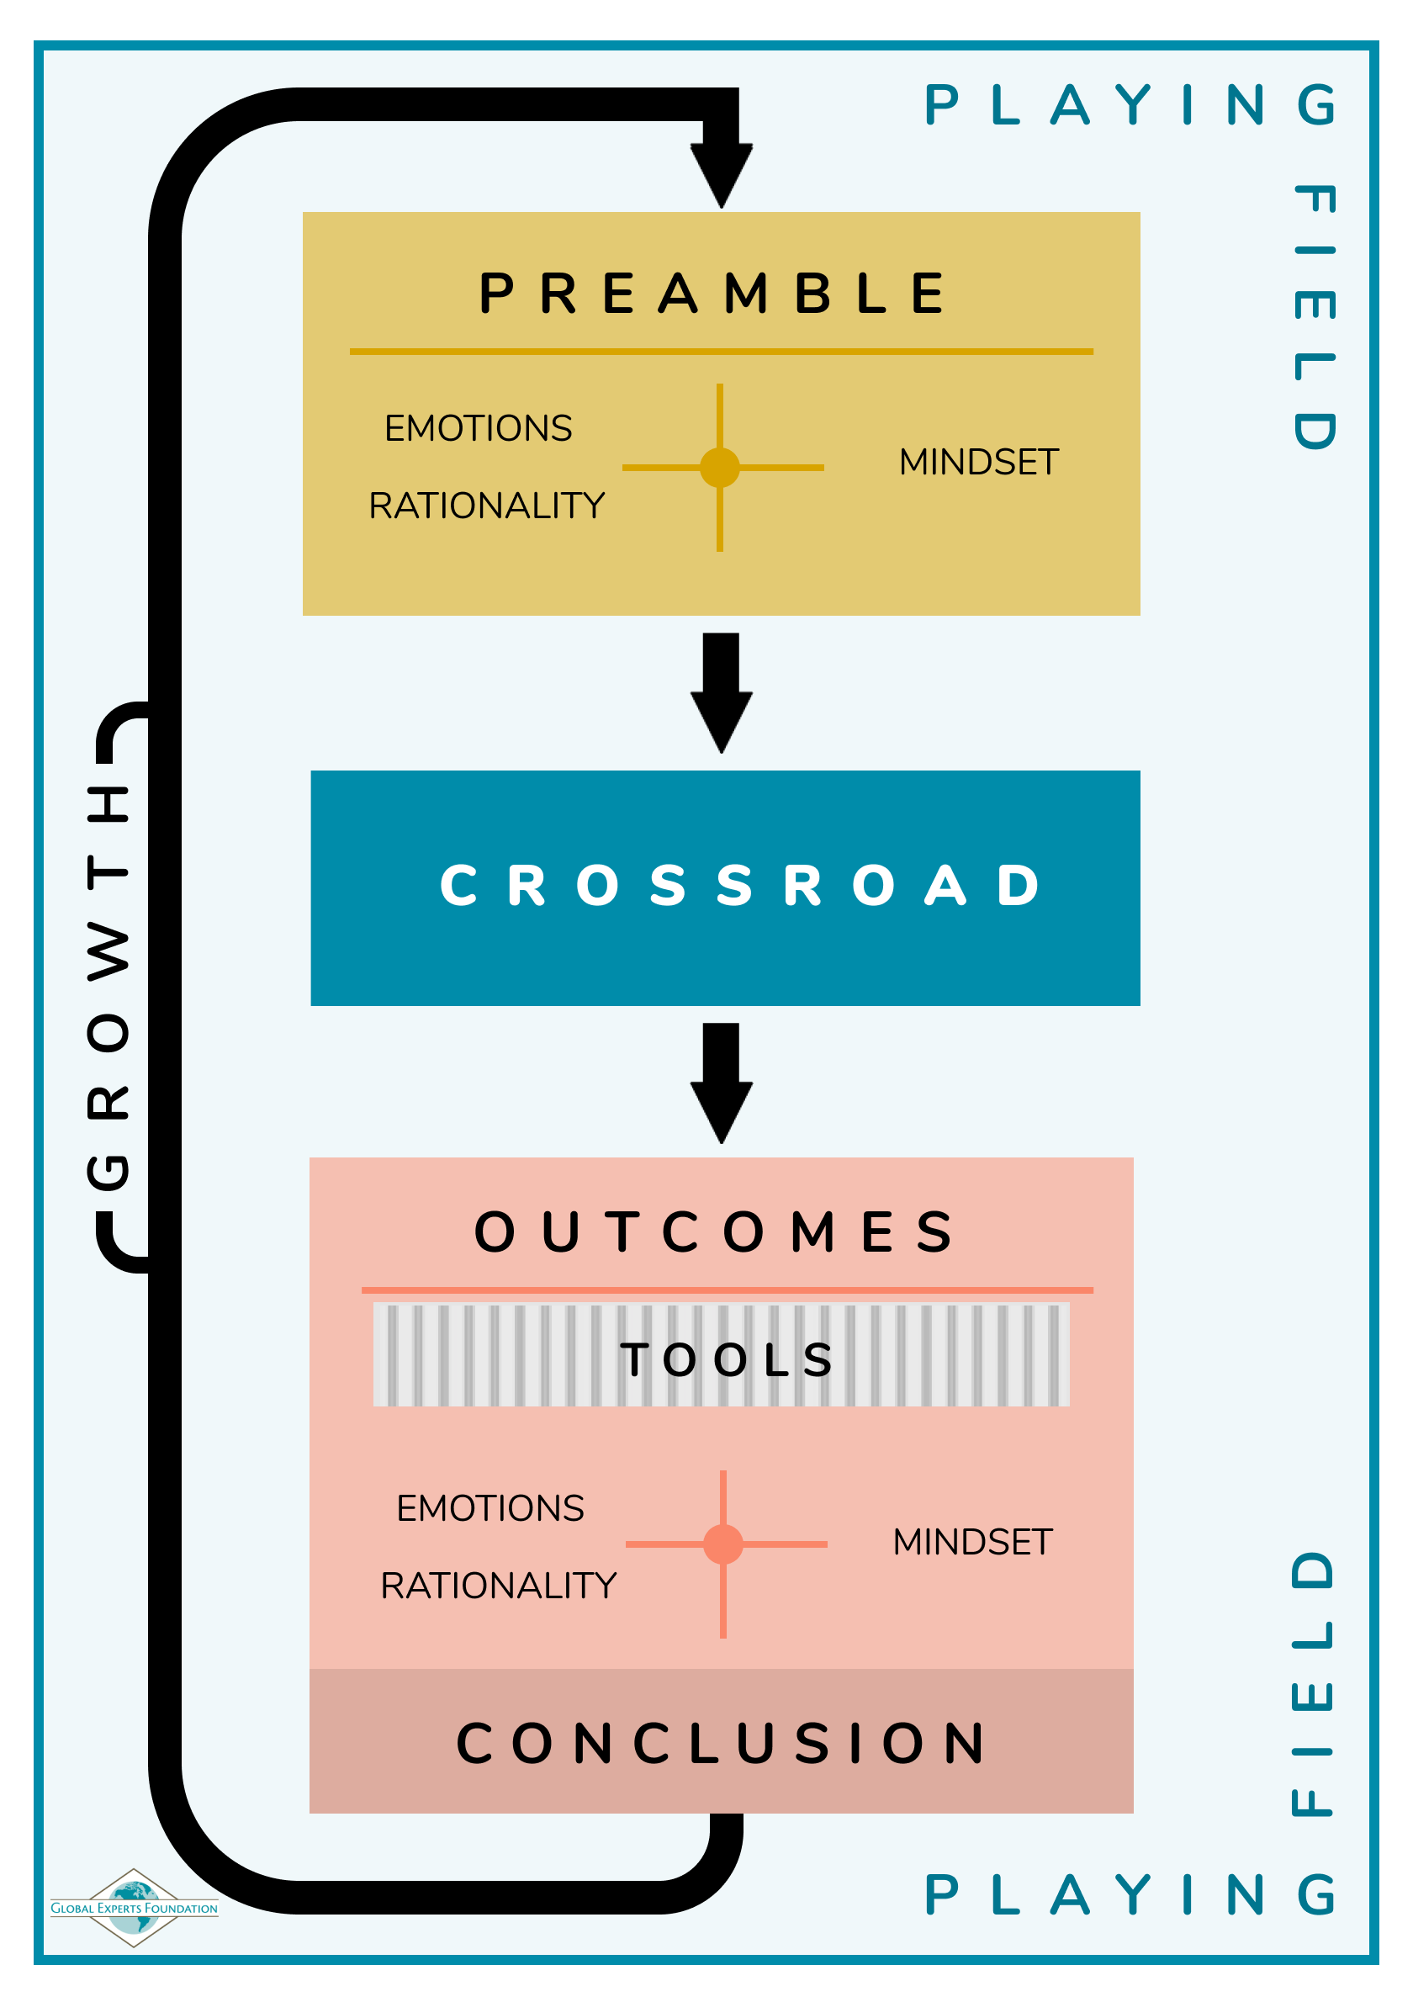

**Applying your future decision**



* What is your **crossroad (impactful decision)**?
* Why are you leaning one way or the other? What are the **reasons** behind your decision (preamble)?
  + What is the balance between internal and external?
* How does your **playing field** influence your decision?
  + Supportive, discouraging, aligned with your thoughts/feelings?
  + How do you feel about this influence?
* What role do your **emotions, rationality** and **mindset** currently play in your decision?
  + What emotions and thoughts are coming up for you during this process? Why?
  + What are you focused on? Worries? Positive? Opportunities? Negative? Why?
* When you reflect on these questions and your decision-making process, what are two challenges that come up for you?`
  + What is difficult about them?
  + What do they confront you with specifically?

Can’t have it all, choose and that is okay

Ask what we value the most

**TOOLS**



Talk to friends*

Different perspectives

Limit external input

Imposter syndrome

Living situation

Failure / uncertainty

**CHALLENGES**

Not meeting job requirements

Family plans

FOMO-social media

Financial limitations

Different does not mean better

Look beyond the context – what underlying elements do I like about this - can apply in many other places – don’t limit myself to the thing (chef example)

Everyone in the same boat

Learn through having exp.

Also people that left the field – professors

Accept the imperfection

Talking to people already in the field



Learn from what you experienced

Also to stay confident

Leaning on past experiences – was able to succeed even if it was difficult

-Just do it

Keep going

See what happens

Communication (talking to the people and talking to others in the team)

**TOOLS**

Being flexible

Explore the phase and see what sticks

Seeing something as an opportunity to learn

Being fine with not understanding something, and just learning it

Trust in my ability to be good enough (skills)

Not being prepared

What the hell do I do?!

Fear of missing out

Doubting myself about difficult course

**CHALLENGES**

High-output pressure society

So many options

Finding out what it is that you like about the passion and the work and apply that in everything you do

Using your decision-making as a tool

Not being topic-dependent

Accepting consequences



**Our future**

**Our future**



**GYL Takeaways**



**Connect & reach out!**

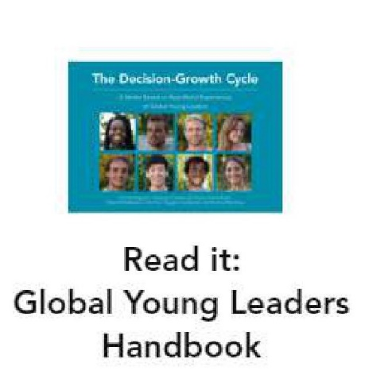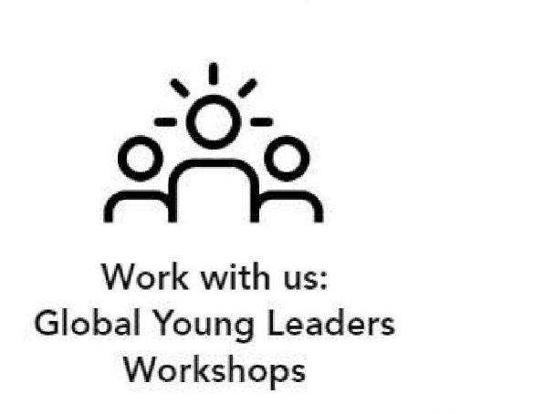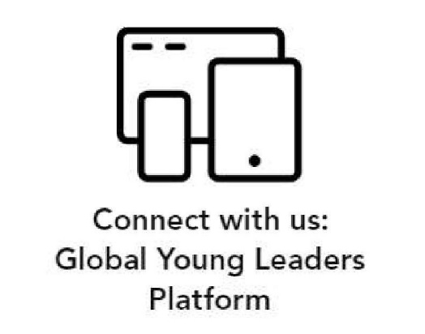

**Website:** [**www.global-youngleaders.com**](http://www.global-youngleaders.com)

**Email:** [**gyl@global-expertsfoundation.com**](mailto:gyl@global-expertsfoundation.com)

**Instagram: @globalyoungleaders**

**Facebook: Global Young Leaders**

**Community: community.global-youngleaders.com**

